Lab - 2: Properties of Signals and Systems
EXERCISES
1) Illustrate time and amplitude scaling of an input signal in MATLAB
CODE
% Define time vector
t = -2*pi:0.01:2*pi; % Time from -2pi to 2pi with small steps
x = sin(t); % Original signal (a sine wave)

% Time scaling
x_compressed = sin(2*t); % Time compressed signal (faster, by a factor of 2)
x_stretched = sin(t/2); % Time stretched signal (slower, by a factor of 2)

% Amplitude scaling
x_amplified = 2 * sin(t); % Amplitude doubled (amplified)
x_attenuated = 0.5 * sin(t); % Amplitude halved (attenuated)

% Plot original signal
figure;
subplot(3,1,1);
plot(t, x, 'b', 'LineWidth', 1.5);
title('Original Signal (sin(t))');
xlabel('Time (t)');
ylabel('Amplitude');
grid on;

% Plot time scaled signals
subplot(3,1,2);
plot(t, x_compressed, 'r', t, x_stretched, 'g', 'LineWidth', 1.5);
title('Time Scaling: Compressed (red) and Stretched (green)');
xlabel('Time (t)');
ylabel('Amplitude');
grid on;

% Plot amplitude scaled signals
subplot(3,1,3);
plot(t, x_amplified, 'm', t, x_attenuated, 'c', 'LineWidth', 1.5);
title('Amplitude Scaling: Amplified (magenta) and Attenuated (cyan)');
xlabel('Time (t)');
ylabel('Amplitude');
grid on;

Graph

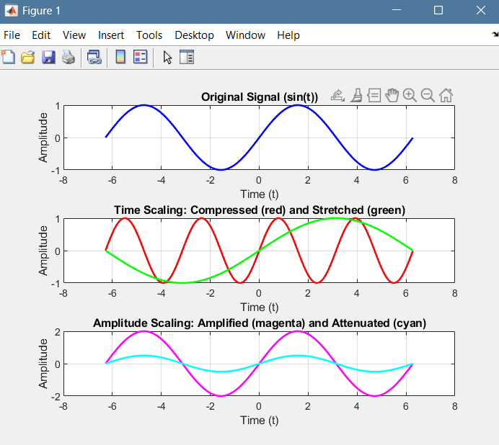
2) Illustrate time and amplitude shifting of an input signal in MATLAB.
CODE
% Define time vector
t = -2*pi:0.01:2*pi; % Time from -2pi to 2pi with small steps
x = sin(t); % Original signal (a sine wave)

% Time shifting
x_shift_right = sin(t - pi/2); % Shift right by pi/2
x_shift_left = sin(t + pi/2); % Shift left by pi/2

% Amplitude shifting
x_shift_up = sin(t) + 1; % Shift amplitude up by 1
x_shift_down = sin(t) - 1; % Shift amplitude down by 1

% Plot original signal
figure;
subplot(3,1,1);
plot(t, x, 'b', 'LineWidth', 1.5);
title('Original Signal (sin(t))');
xlabel('Time (t)');
ylabel('Amplitude');
grid on;

% Plot time shifted signals
subplot(3,1,2);
plot(t, x_shift_right, 'r', t, x_shift_left, 'g', 'LineWidth', 1.5);
title('Time Shifting: Right Shift (red) and Left Shift (green)');
xlabel('Time (t)');
ylabel('Amplitude');
grid on;

% Plot amplitude shifted signals
subplot(3,1,3);
plot(t, x_shift_up, 'm', t, x_shift_down, 'c', 'LineWidth', 1.5);
title('Amplitude Shifting: Upward Shift (magenta) and Downward Shift (cyan)');
xlabel('Time (t)');
ylabel('Amplitude');
grid on;

Graph
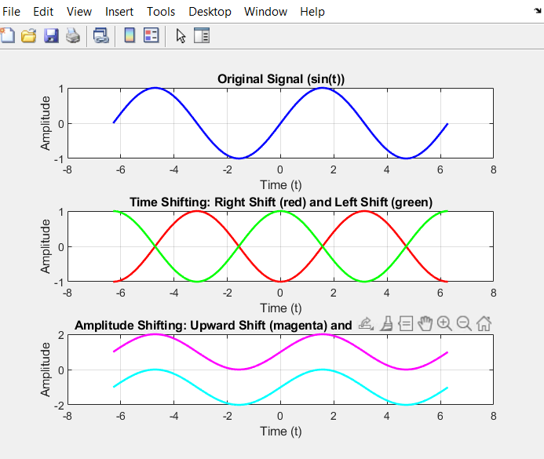
3) illustrate time and amplitude reversal of an input signal in MATLAB.
CODE
% Define time vector
t = -2*pi:0.01:2*pi; % Time from -2pi to 2pi with small steps
x = sin(t); % Original signal (a sine wave)

% Time reversal
x_time_reversed = sin(-t); % Time reversed signal

% Amplitude reversal
x_amplitude_reversed = -sin(t); % Amplitude reversed signal

% Time and Amplitude reversal combined
x_time_amp_reversed = -sin(-t); % Both time and amplitude reversed

% Plot original signal
figure;
subplot(4,1,1);
plot(t, x, 'b', 'LineWidth', 1.5);
title('Original Signal (sin(t))');
xlabel('Time (t)');
ylabel('Amplitude');
grid on;

% Plot time reversed signal
subplot(4,1,2);
plot(t, x_time_reversed, 'r', 'LineWidth', 1.5);
title('Time Reversal (sin(-t))');
xlabel('Time (t)');
ylabel('Amplitude');
grid on;

% Plot amplitude reversed signal
subplot(4,1,3);
plot(t, x_amplitude_reversed, 'g', 'LineWidth', 1.5);
title('Amplitude Reversal (-sin(t))');
xlabel('Time (t)');
ylabel('Amplitude');
grid on;

% Plot time and amplitude reversed signal
subplot(4,1,4);
plot(t, x_time_amp_reversed, 'm', 'LineWidth', 1.5);
title('Time & Amplitude Reversal (-sin(-t))');
xlabel('Time (t)');
ylabel('Amplitude');
grid on;

Graph
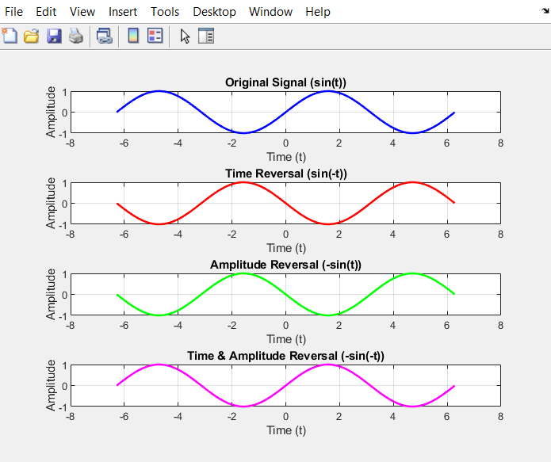

4) a) What is the difference between digital and discrete signal?
b) Are the signals in MATLAB discrete time or continuous time, digital or analog?
(4a) Difference Between Digital and Discrete Signals:
1. Discrete Signal:
A discrete signal is defined as a signal that is sampled in time. In other words, it exists only at specific intervals of time, not continuously.
It can be analog or digital.
Example: Sampling an analog signal at specific time intervals (e.g., ( t = 0, 1, 2, 3, …)) results in a discrete signal.
2. Digital Signal:
A digital signal is both discrete in time and discrete in amplitude (quantized).
The amplitude of the signal takes values from a finite set (e.g., 0s and 1s in binary systems).
Digital signals are the ones that computers or digital systems typically use, as the values are represented in binary (0 and 1).
Example: When both the time samples and amplitudes are represented by binary values, it becomes a digital signal.
Key Differences:
Time Domain:
Discrete signals: Time is discrete, but amplitudes can still be continuous.
Digital signals: Time is discrete, and amplitudes are also discrete (quantized).
Amplitude Domain:
Discrete signals: Amplitudes can be continuous (analog).
Digital signals: Amplitudes are quantized (e.g., only certain levels are allowed, typically binary).
(4b) Are Signals in MATLAB Discrete-Time or Continuous-Time, Digital or Analog?
Signals in MATLAB:
1. Discrete-Time Signals:
In MATLAB, signals are generally represented as discrete-time signals. This is because MATLAB uses arrays to store and process signals, and these arrays represent samples at discrete time intervals.
Even if the signal is meant to model a continuous-time system (e.g., (sin(t))), it is sampled at specific intervals when implemented in MATLAB. This makes it discrete time.

2. Analog or Digital:
In MATLAB, the signals are generally treated as analog in terms of amplitude because the values can be continuous (real numbers).
However, if you quantize the amplitude values (round or map them to certain levels), then the signal becomes digital.

5) Record your sound saying the sentence, “The quick brown fox jumps over the lazy dog”. Play this recording in MATLAB with and without time reversal, also comment on the observations.
CODE
% Load the recorded audio file
[audio, fs] = audioread('C:\Users\hassaan/\Downloads\The Quick Brown Fox Jumps Over The Lazy Dog [ ezmp3.cc ].mp3'); % Replace with the actual file path
duration = length(audio) / fs; % Calculate duration of the audio

% Play the original audio
disp('Playing original recording...');
sound(audio, fs);
pause(duration + 1); % Wait for the audio to finish

% Reverse the audio in time
audio_reversed = flipud(audio);

% Play the time-reversed audio
disp('Playing time-reversed recording...');
sound(audio_reversed, fs);

% Plot original and reversed waveforms
t = (0:length(audio)-1)/fs; % Time vector for plotting

figure;
subplot(2,1,1);
plot(t, audio, 'b');
title('Original Recording');
xlabel('Time (s)');
ylabel('Amplitude');
grid on;

subplot(2,1,2);
plot(t, audio_reversed, 'r');
title('Time-Reversed Recording');
xlabel('Time (s)');
ylabel('Amplitude');
grid on;

Graph
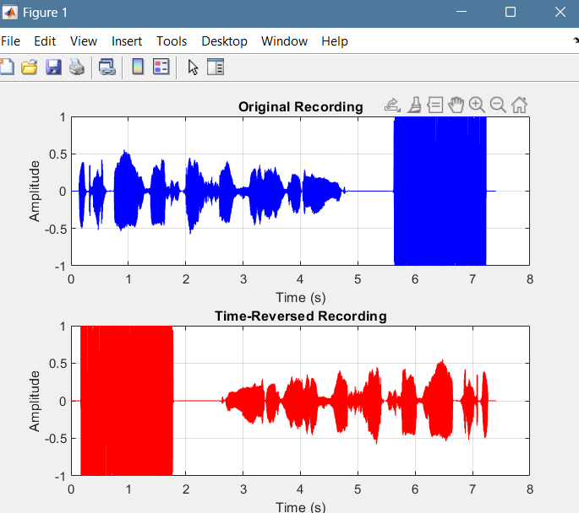

6)Play the sound recording of the previous question after and before expansion and compression. What is the expansion and compression factor? (i.e. up sampling and down sampling factor)

CODE
% Load the recorded audio file
[audio, fs] = audioread('C:\Users\hassaan\Downloads\The Quick Brown Fox Jumps Over The Lazy Dog [ ezmp3.cc ].mp3'); % Replace with the actual file path
duration = length(audio) / fs; % Calculate duration of the audio

% Define expansion and compression factors
expansion_factor = 2; % Example: 2x slower (time expansion)
compression_factor = 2; % Example: 2x faster (time compression)

% Time vector for original signal
t_original = (0:length(audio)-1) / fs;

%% Expansion (Upsampling by a factor of 2)
new_fs_expansion = fs / expansion_factor; % Reduce the sampling rate by expansion factor
t_expanded = (0:length(audio)-1) / new_fs_expansion; % Time vector for expanded signal

%% Compression (Downsampling by a factor of 2)
new_fs_compression = fs * compression_factor; % Increase the sampling rate by compression factor
t_compressed = (0:length(audio)-1) / new_fs_compression; % Time vector for compressed signal

% Plot the original, expanded, and compressed signals on the same figure
figure;

subplot(3,1,1);
plot(t_original, audio, 'b');
title('Original Audio Signal');
xlabel('Time (s)');
ylabel('Amplitude');
grid on;

subplot(3,1,2);
plot(t_expanded, audio, 'r');
title('Expanded Audio Signal (Slower)');
xlabel('Time (s)');
ylabel('Amplitude');
grid on;

subplot(3,1,3);
plot(t_compressed, audio, 'g');
title('Compressed Audio Signal (Faster)');
xlabel('Time (s)');
ylabel('Amplitude');
grid on;

% Play the original audio
disp('Playing original recording...');
sound(audio, fs);
pause(duration + 1); % Wait for the audio to finish

% Play the expanded (slower) audio
disp('Playing expanded (slower) audio...');
sound(audio, new_fs_expansion);
pause(duration * expansion_factor + 1); % Wait for the expanded audio to finish

% Play the compressed (faster) audio
disp('Playing compressed (faster) audio...');
sound(audio, new_fs_compression);
pause(duration / compression_factor + 1); % Wait for the compressed audio to finish

Graph
